Explainable AI for Intrusion Detection Systems: LIME and SHAP Applicability on Multi-Layer Perceptron

Abstract
Intrusion Detection Systems (IDS) play a pivotal role in ensuring network security by identifying malicious traffic and safeguarding against Advanced Persistent Threats (APTs). With the exponential rise of cyberattacks, machine learning (ML) and deep learning (DL) approaches have been widely adopted to improve intrusion detection accuracy. In this work, we present an Explainable Artificial Intelligence (XAI)-based framework for intrusion detection using the CIC-IDS dataset. Two state-of-the-art deep learning models, Long Short-Term Memory (LSTM) and Temporal Convolutional Network (TCN), were implemented and compared in terms of precision, recall, F-score, accuracy, confusion matrix, and ROC curve. To evaluate model robustness, perturbations were added to the test data, simulating real-world unknown attacks. Remarkably, both algorithms sustained high accuracy, achieving more than 98%, with LSTM outperforming TCN at 99.88%. The explainability aspect was incorporated using SHAP (SHapley Additive exPlanations), which provided insights into feature importance and contribution toward prediction. SHAP summary and violin plots highlighted critical network traffic attributes influencing classification, thereby enhancing model transparency and trustworthiness for cybersecurity applications. The system was implemented as an interactive GUI-based application comprising modules for dataset upload, preprocessing, model training, algorithm execution, performance comparison, and XAI-based model interpretation. The experimental results demonstrate the efficacy of LSTM and TCN in intrusion detection, with LSTM providing superior performance. Moreover, the inclusion of explainable AI bridges the gap between black-box DL models and human interpretability, which is vital for cybersecurity experts in decision-making processes. This study confirms that integrating robust deep learning architectures with explainable AI significantly enhances the accuracy, interpretability, and practical applicability of IDS in detecting sophisticated intrusions.
Keywords
Intrusion Detection System, Explainable AI, LSTM, TCN, SHAP, CIC-IDS, Deep Learning, Cybersecurity
Existing System
The existing intrusion detection systems rely heavily on traditional machine learning algorithms or shallow models such as Decision Trees, Naïve Bayes, and Support Vector Machines. These approaches, although effective in some cases, often fail to capture the complex temporal dependencies and sequential patterns present in large-scale network traffic. Moreover, most of these models act as black-box predictors without providing clear reasoning or interpretability behind their predictions. While they offer moderate accuracy, their robustness against adversarial attacks or perturbed test data remains limited, reducing their applicability in real-world dynamic intrusion environments.
Disadvantages of Existing System
- Limited ability to capture temporal and sequential dependencies in network traffic.
- Lack of robustness when tested against unseen or perturbed data.
- Poor interpretability, making them less reliable for expert decision-making.

Proposed System
The proposed system introduces advanced deep learning models—LSTM and TCN—trained on the CIC-IDS dataset for intrusion detection. Both models are evaluated on pre-processed, normalized datasets, achieving accuracy beyond 98% even under perturbed test conditions. Additionally, explainability is integrated through SHAP, which identifies feature importance and highlights how specific network attributes contribute to prediction outcomes. This improves not only detection accuracy but also model transparency, enabling security analysts to trust and validate the results. A GUI-based interactive framework is implemented for seamless execution of modules, comparison of results, and visualization of SHAP-based explanations, ensuring both robustness and interpretability.
Advantages of Proposed System
- Achieves superior accuracy (up to 99.88%) with LSTM, even under perturbed test scenarios.
- Provides explainability using SHAP, enhancing model trust and transparency.
- GUI-based implementation offers user-friendly interaction, real-time analysis, and better decision support.

Modules Description
To implement this project, we have implemented following modules:
- Upload CICIDS Dataset: using this module we will upload dataset details and then application will read and display dataset values and then find and plot graph of normal and attack count
- Pre-process Dataset: using this module we will apply pre-process technique on dataset to remove missing values and then convert all non-numeric data into numeric data
- Train & Test Split: using this module will split dataset into train and test where application using 80% dataset for training and 20% for testing
- Run LSTM Algorithm: using this module we will input 80% dataset to LSTM to train a model and 20% test data will be applied on trained model to calculate prediction accuracy
- Run TCN Algorithm: using this module we will input 80% dataset to TCN to train a model and 20% test data will be applied on trained model to calculate prediction accuracy
- Comparison Graph: using this module we will plot accuracy comparison graph between all algorithms
- Summary Model Explanation: using this module will explain model performance using summary plot which will show which features contribute most for correct prediction
- Violin Model Explanation: using this module will explain model performance using violin plot which will show which features contribute most for correct prediction
- Predict Attack from Test Data: using this module we will upload test data and then LSTM model will analyse dataset and then predict weather dataset contains normal or attack features

SYSTEM ARCHITECTURE
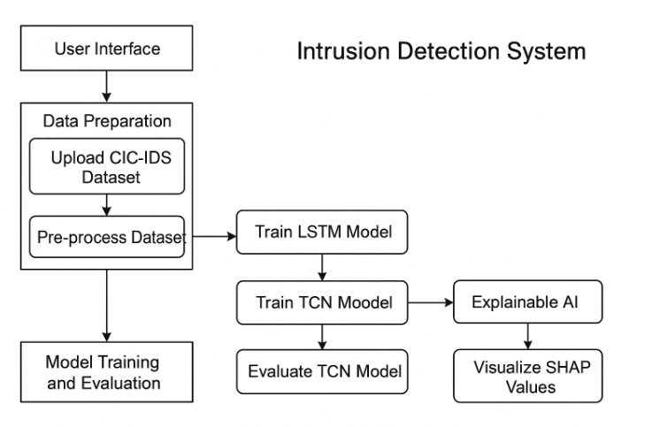
HARDWARE & SOFTWARE REQUIREMENTS:
HARDWARE REQUIRMENTS:
- Processor : Intel I3 (min)
- Hard Disk : 500 GB (min).
- Ram : 4 GB (min).
SOFTWARE REQUIRMENTS:
- Operating system : Windows 10 (min)
- Coding Language : python (3.7.0)

